「話仙 kiafm罔寫」 03/17/2021 第一節：

Zhengbeeng
清明

Thienzhefng khiebeeng、Saobong zeazor
天清氣明、掃墓祭祖

Zhengbeeng siong ho laang hoailiam ee si zhwkhakkøea
清明尚乎人懷念的是鼠麴粿

Uxlaang korng si zhwkhakkøea, ma uxlaang korng si zhawafkøea iafsi zhuokakkøea
有人講是鼠麴粿，也有人講是草仔粿還是厝角粿

Iukii si tviphøee kiamva paw zhaepofbie ee zhwkhakkøea, siong høfciah
尤其是甜皮鹹餡包菜脯米的鼠麴粿，尚好食

Liexnsip
練習

Zhefng、Zhengbeeng、Zhengbengcied
清、 清明、 清明節

zhaix、zhaepor、zhaepofbie
菜、 菜脯、 菜脯米

** 鼠麴粿 現代文寫成
zhwkhakkøea

厝角粿 現代文寫成
zhuokakkøea
=============================
Zhengbeeng

Thienzhefng khiebeeng、Saobong zeazor

Zhengbeeng siong ho laang hoailiam ee si zhwkhakkøea.

Uxlaang korng si zhwkhakkøea, ma uxlaang korng si zhawafkøea iafsi zhuokakkøea.

Iukii si tviphøee kiamva paw zhaepofbie ee zhwkhakkøea, siong høfciah.

Liexnsip

Zhefng、Zhengbeeng、Zhengbengcied
zhaix、zhaepor、zhaepofbie

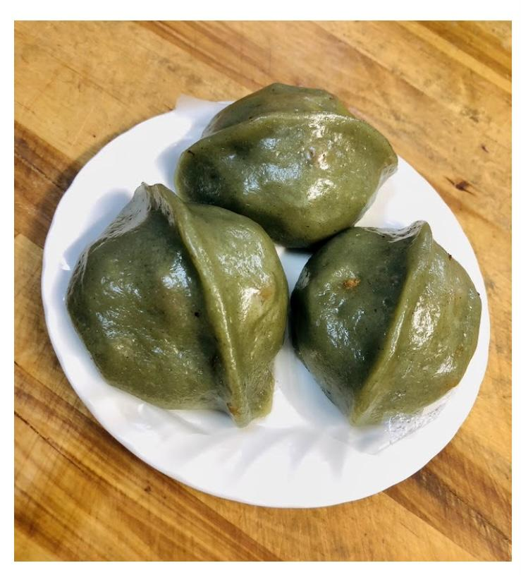

Additional Q & A in the Line Thread:

- How to verify the meaning of Taiwanese? "Hiexntai-buun" Dictionary Search:
http://taioaan.org/taigie/english/jixtiern/match.php?exact=2&ndic=0&word=toaxc

- 培墓的「培」本身是：pøe。所以，「培墓的」「培」在「培墓」時由基調轉調成下突，寫成pøexbong
- 掃：saux
- 掃墓： saobong

